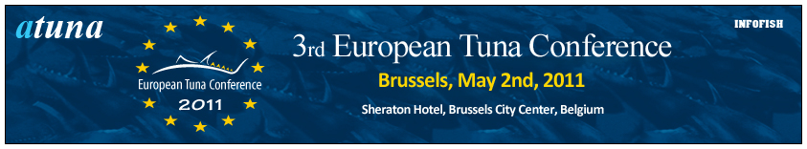

APPLICATION FORM

Europe’s Best Tuna TV Commercial Award 2011

Please email this form before April 18th 2011 to: support@europeantunaconference.com

Commercial name:
Description of the product, brand, company or service:
European countries where the commercial was introduced:
Launch date of the commercial:

Commercial development PR Agency:
Company name:
Contact person:
Company address:
Company phone:
Company email:
Date of sending:
Way of sending:
Courier AWB#:

Important:
To enter the competition:
- a representative from the participating company must be a registered delegate to the conference.
- the Tuna TV Commercial must have been broadcasted on TV between May 2009 and April 2011 in any European market.
Participants are asked to either provide us with the location where we can download their TV commercial, or submit their video on a DVD.
Please send your Tuna TV Commercial DVD to:
Atuna bv
European Tuna Conference
Meerpaal 14d
4904 SK Oosterhout
The Netherlands
All the competing commercials will be viewable prior to the conference on www.europeantunaconference.com and will only be accessible through this site.
"Europe’s Best Tuna TV Commercial 2011 Award" will be handed out during the Cocktail Party at the end of the Conference – which will take place on the top floor of the Sheraton Hotel.

